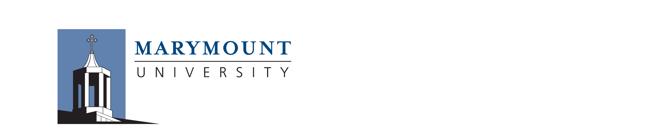RELEASE AND WAIVER OF LIABILITY
This following activity is being offered through Marymount University in Arlington, VA. As used herein, “Marymount” includes Marymount University, the MU DEPARTMENT Athletics and their employees, agents, officers, directors, and affiliates.

Activity: __Cheer Team Tryouts

Date(s): April 28, 2019

I acknowledge that I am entering into this waiver and release of liability knowingly and voluntarily. I assume all responsibility and assume all risk associated with participation in this Activity. I fully acknowledge and recognize that risks may be involved in this Activity, and that such risks may include physical or psychological injury, including but not limited to illness, paralysis, death, damages, economic or emotional loss, that I may suffer as a direct or indirect result of my participation in the Activity, including travel to and from the Activity.

I release Marymount from all liability, damages, or causes of action, known or unknown, from personal injury, property damage or death which may result in whole or in part either directly or indirectly as a result of my participation. I also release, indemnify and hold harmless Marymount for any bodily injury, death or property damage to me while being transported by vehicle by a Marymount faculty or staff member or other designated driver.

I fully understand my responsibility as a participant in the above named activity to act in a responsible and prudent manner. I also understand that any university faculty or staff in attendance will be acting in an advisory capacity only. I understand that Marymount assumes no responsibility for my personal safety or the welfare of my property and belongings in this activity, and that I alone assume all risk associated with this activity.

I hereby release, waive, indemnify and hold harmless Marymount as defined above from any and all damages, claims, liabilities, responsibilities or other expenses for personal injury or property damage resulting in whole or in part from, or otherwise in connection with, my participation in this activity.

I acknowledge that I have read this document carefully and fully understand its contents. I agree that, should any provision or aspect of this agreement be found to be unenforceable, that all remaining provisions of the agreement will remain in full force and effect.

Participant Signature: ______________________________________ Date: ___________

Participant Printed Name: ___________________________________

Participant Address: ______________________________________ City: ___________ State: __ Zip: _______

Phone#(s): Day: _______________ Night: ________________ Cell: __________________

Participant Status: Undergraduate: __ Graduate: __ Faculty: __ Staff: __ Visitor/Volunteer/Contractor: _______

